CS5338 – Formal Languages

Spring 2019 – Assignment 4

Due: April 12, 2019

Submitted By

Ahmed Raza,

a_r904,

A04775175

**1. (20 pts) Convert the following CFG into an equivalent CFG in Chomsky normal form.**

**A → BAB | ABA | B | ∈**

**B → 00 | ∈**

We introduce a new start symbol S and obtain the following CFG

S → A

A → BAB | ABA | B | ∈

B → 00 | ∈

After ∈-rule elimination, we generate the following CFG

S → A∈

A → BAB | ABA | B | BA | AB | AA | BB |

B → 00

After unit rule elimination, we generate the following CFG

S → BAB | ABA | BA | AB | AA | BB | 00 | ∈

A → BAB | ABA | BA | AB | AA | BB | 00

B → 00

We now convert the above rules into the proper form

S → BU | AV | BA | AB | AA | BB | WW | ∈

A → BU | AV | BA | AB | AA | BB | WW

B → WW

U → AB

V → BA

W → 0

**2. (20 pts) Use the pumping lemma to prove that the language**

**A = {02n 13n 0n | n ≥ 0} is not context free.**

Assume that A is a CFL, Let P be the pumping length of the pumping lemma for CFLs, and consider string s = 0^2p 1^3p 0^P ∈ A

Note that |s|= 6p>p, so the pumping lemma will hold.

Thus, there exists strings u,v,x,y,z such that

S = uvxyz = 0^2p 1^3p 0^p

Where u v^i x y^i z ∈ A for all i >= 0 and |vy| >= 1

We now consider all of the possible choices for v and y

Suppose string v and y are uniform (e.g. v=0^j for some j >= 0, and y = 1^k for some k >= 0)

Then |vy| >= 1 implies that j >= 1or k >= 1(or both)

So, u v^2 x y^2 z wont have the correct number of 0’s at the beginning, 1’s in the middle, 0’s at the end. Hence, u v^2 x y^2 z ∉ A.

Now suppose string v and y are not both uniform.

Then u v^2 x y^2 z will not have the form 0…01…10…0.

Hence, u v^2 x y^2 z ∉ A.

Thus, there are no options for v and y such that u v^i x y^i z ∈ A for all i >= 0. This is a contradiction, so A is not a CFL.

**3. (30 pts) The Turing machine M below recognizes the language A = {0"# | n ≥ 0}.**

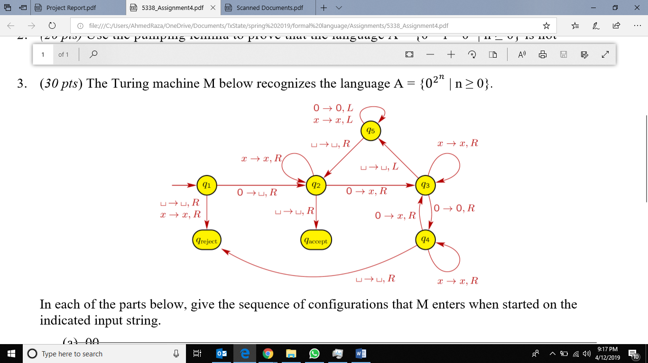

**In each of the parts below, give the sequence of configurations that M enters when started on the indicated input string.**

**(a) 00**

q1 00 ︺q2 0 ︺xq3︺ ︺q5x

q5︺x ︺q2x ︺xq2︺ ︺x︺q accept.

**(b) 000000**

q1 000000 ︺q2 00000 ︺xq3 0000 ︺x0q4 000

︺x 0xq3 00 ︺x0x0q4 0 ︺x 0x0xq3︺ ︺x0x0q5 x

︺x0xq5 0x ︺x0q5 x0x ︺xq5 0x0x ︺q5 x0x0x

q5 ︺x0x0x ︺q2 x0x0x ︺xq2 0x0x ︺xxq3 0x0

︺xxxq3 0x ︺xxx0q4 x ︺xxx0xq4︺ ︺xxx0x︺q reject.

**4. (20 pts) Construct a Turing machine that accepts the complement of the language**

L = L (aaaa* b*).

A TM M that accepts L can be constructed as follows,

Assume that Σ{a,b}

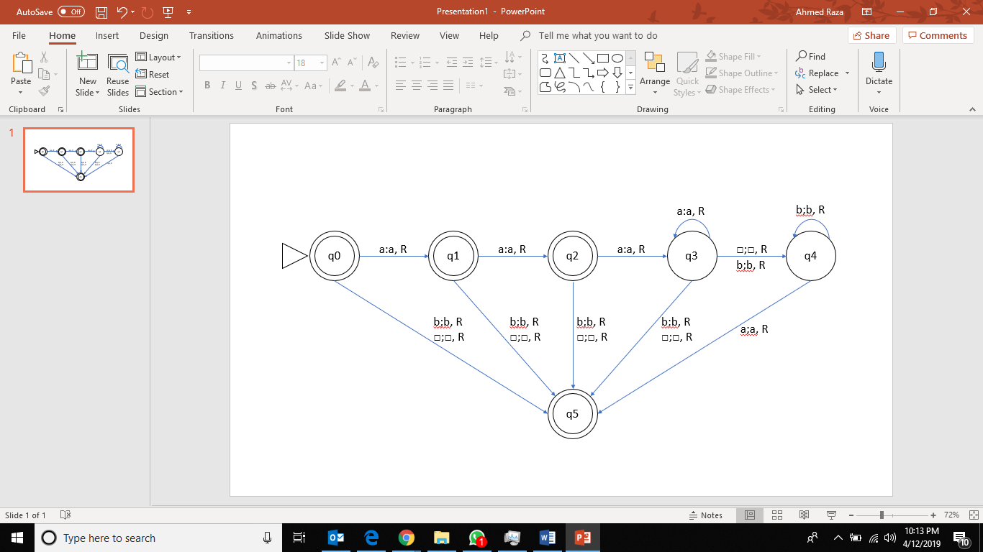

**5. (10 pts) What language is accepted by the Turing machine whose transaction graph is in the figure below?**

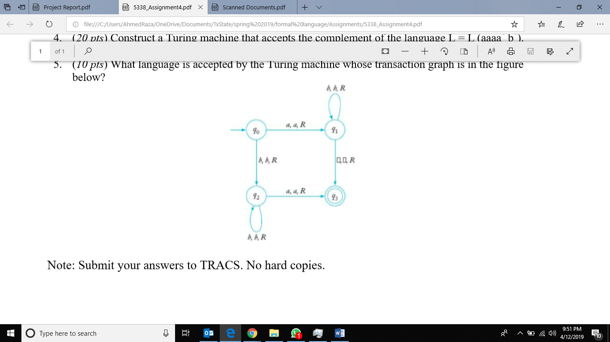

L= ab* + bb*a